**Intro to VB.Net**

The purpose of this document is to give you a little introduction in VB.Net with assumption that you have a little programming background more particularly in Visual C++ which the programming of choice in IS220.

First VB.net like C++ (or Java or C#) is an object-oriented language meaning an object (which I shall define and detail in a moment) is a first class citizen of the language and at the heart of the language. The different tools for example in the Tool Bar (as you will see in a moment) like a Textbox, Button, Label etc are examples of objects (visual ones) in VB.Net. Now, VB.net is based also on the dotnet Framework which unfortunately for the sake of simplicity and that would simply accomplish what we need to know for our project will not be discuss here for the moment.

Now, let’s look at the different parts of the Work Area for VB.Net below:

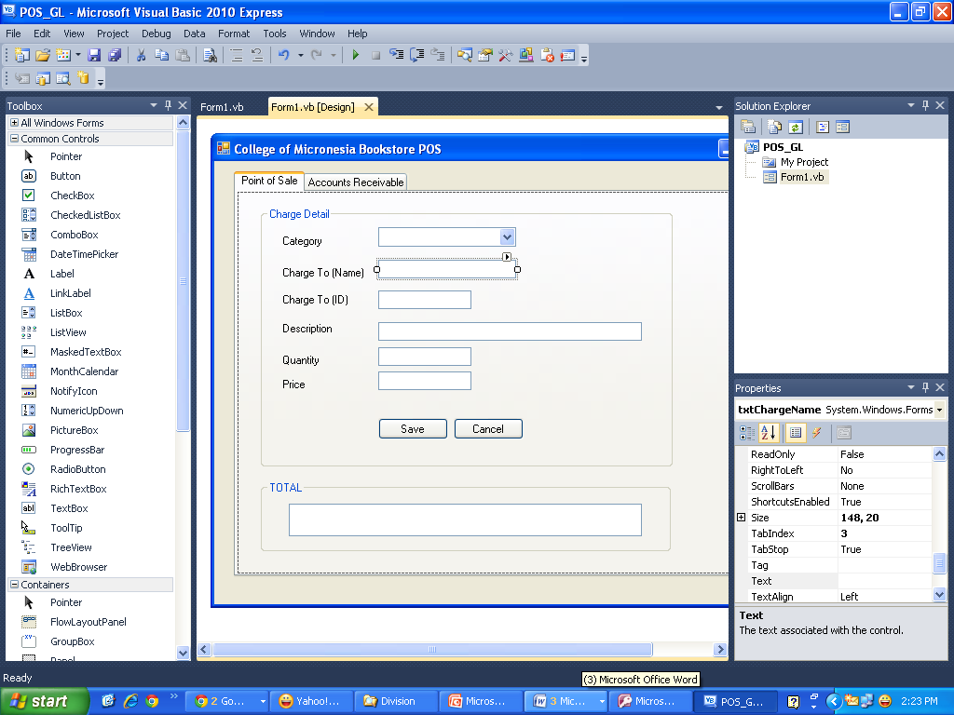

**Solution Explorer**

**Property Window**

**Form Designer**

**ToolBox**

**ToolBox** – contains the ready-made tools that you could use for your project. For example Textbox, Label, Button, ComboBox, GroupBox, DataGrid are few examples that you could use from the Tool Box. If it so happens that the ToolBox is not showing up you could press Ctrl+Alt+X or you could click on the Tool bar as shown below:



**ToolBox**

**Property Window** – allows you to see the Property of your Object. For example if I have a TextBox I could see in my property window the Name of my textbox (e.g. Textbox1), font it use, the Alignment, the Size etc. If you could not see a Property Window make sure that you are in a Form Designer and then Press F4 or you could click in the Tool bar as shown below:



**Property Window**

**Solution Explorer** – allows you to see the Project that you have under your Solution that you created and all the different items included like for example the Form, the Class etc. If you could not see the Solution Explorer Press Ctrl+Alt+L or click in the Tool bar as shown below:



**Solution Explorer**

Now, there are more still like Class Window, Database Explorer etc. But we will tackle one more important one, namely, the **Code Designer** window or the Code Behind your Project which includes your Form, Button, Textbox etc. Below is the Code Designer/Behind window:

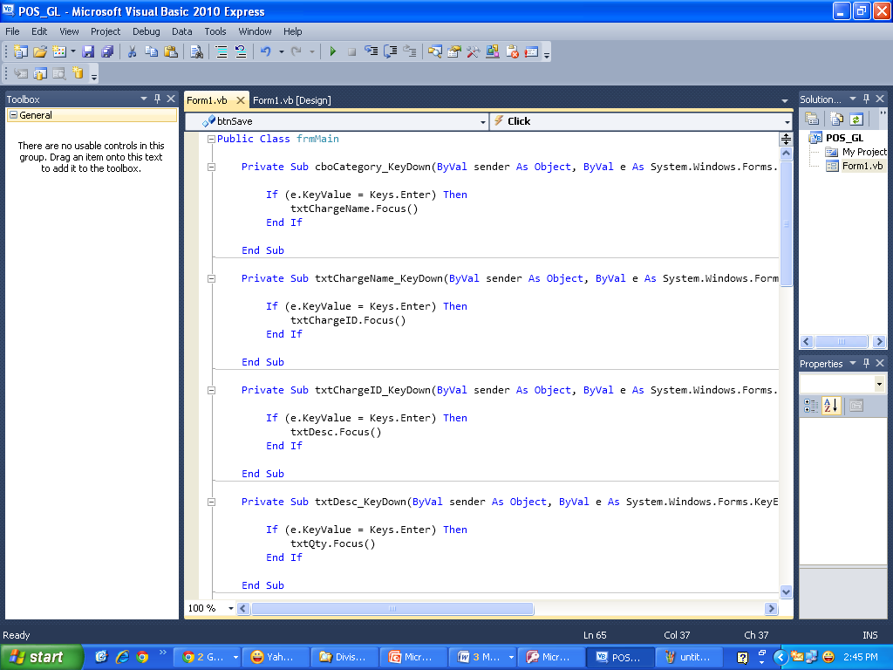

**Code Designer/Behind Window**

**Parallel between C++ and VB.net**

Here I am going to show some parallel between C++ and VB.Net

|  |  |  |
| --- | --- | --- |
| **Description** | **C++** | **VB.Net** |
| **Declaring a Variable** | int x;  double y;  int age=20, year; | Dim x as Integer  Dim y as Double  Dim age=20, year as Integer |
| **Using For loop** | for(int i=1; i<=10;i++)  {  cout << “i = “ << i;  } | For i as Integer = 1 to 10  Console.WriteLine(i)  Next |
| **Using Do While** | int x=0;  do while (x<=10)  {  Cout << “x =” << x;  x++;  } | Dim x as Integer = 0  Do while x <= 10  Console.WriteLine(x)  x=x+1  Loop |
| **Using do..while or Do Until** | int x=0;  do {  Cout << “x =” << x;  x++;  } while (x<=10); | Dim x As Integer = 0  Do Until x = 10  Console.WriteLine(x)  x=x+1  Loop |

**Objects and Classes**

As I have mentioned earlier the heart of VB.Net is the Object. But what is an object in this first place. An object actually in VB.net is simply a running instance in your memory of a Class. A class on the other hand is the template from which the object is derived. For example the Textbox that you put in a form comes from the Textbox of VB.Net more specifically from **System.Windows.Forms.Textbox()** class and so different objects as well like button comes from different classes in your VB.net.

**Object’s Property, Method and Event**

Now, your Object has three major characteristics, namely, Property, Method and Event. **Property** is simply attributes associate with your object. For example again your Textbox has properties like Name, Size, Foreground Color, Background Color, Text Alignment etc. Remember the Property window that we discuss earlier that’s where you could find your property. You could also see a property of your object using the Code Behind. For example If I have a Textbox name Textbox1 and when I go to the Code Behind/Designer I could type Textbox1. and it will show a drop down of different properties associated with Textbox like Text for example. By the way this is called Intellisense in VB.net, that is, the VB.Net would automatically sense based what you type what property (and method) that you need for example. See image below:

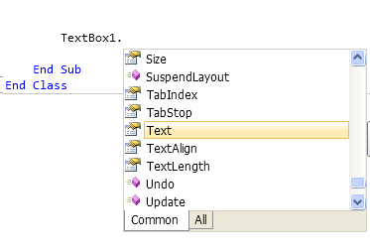

A **Method** or **Methods** on the other hand are actually functions (if you have taken up this in your C++) in an object. For example the Textbox has many functions as you see above from our previous example you the one in pink boxes are actually methods. Like in above Undo(), Update() and SuspendLayout(). Think of it this way a Property of an Object is like a Noun in a grammar and Method are like verbs because they are the one that do actions in an object. To give you more example let’s say I want to format my output in my Textbox to a currency format, that is, a value will be preceded by a dollar sign and with decimal places for example $50.25. I could use then a function named FormatCurrency() to achieve this one. For example if I have a Textbox named Textbox1 and I want to format the output to currency in that Textbox with two (2) decimal places, it would be like this:

**Textbox1.Text = FormatCurrency(Textbox1.Text, 2)**

Finally, the last major part of an Object is an **Event**. An **Event** is simply an action that is acted on an object. For example if a button is Click then you are triggering an Event in the button object. If you press a Key in your textbox you are triggering an event either a KeyDown (when you are still pressing your key in the keyboard and it doesn’t show up in your screen), KeyUp (when you remove your finger from the key and it appears on the screen the key that you type) and KeyPress the whole process, that is, from pressing your key down and until you remove your finger from the key and show what you have just typed on the screen. For example below a Button named Button1 is clicked and it shows you the Code Behind after you click the Button:



**DataGrid Object**

I will show an example on DataGrid below and how to add a value in your Data Grid. For example I have a DataGrid named DataGridView1 and I have two columns for that DataGrid. And I want to save the values from my Textbox to that DataGrid, so the code would be like this for example.

Dim i As Integer = DataGridView1.Rows.Add()

DataGridView1.Rows.Item(i).Cells(0).Value = Textbox1.Text

DataGridView1.Rows.Item(i).Cells(1).Value = Textbox2.Text

**Example VB.Net Project**

Let’s make a simple program in VB.net that will compute the discount in terms of dollars based on the input of Price and Discount Percentage. We will also allow the program to receive the name of the customer.

1. Go to your Microsoft Visual Studio Express in Start->All Programs->Microsoft Visual Studio Express
2. Click *New Project* in the Starting page
3. Change *WindowsApplication1* to *Discount*
4. Bring out the Property Window if it is not yet there by clicking it at the toolbar as shown 
5. Go to *(Name)* at the top of the Property as shown below and replace the name *Form1* to *formDiscount*

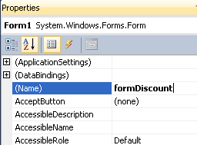

1. Go to Text property as well and changed it from *Form1* to *Discount System*

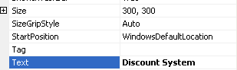

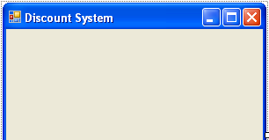

1. Go to the Toolbar and select a Label (shown below) and drop it in your Form

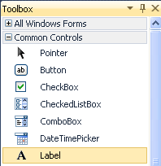

1. Go to the Property window and on Text property give it a name of *Customer Name*

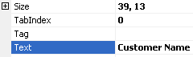

1. Go to the Toolbar again and this time select a Textbox and in (Name) property give it a name *txtCustomername* as shown below

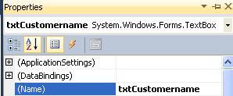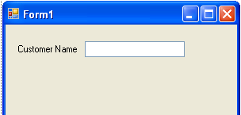

1. And do the rest as you have done earlier

**Object Property Value**

Label Text Price

Textbox (Name) txtPrice

TextAlign Right

Label Text Discount (%)

Textbox Text txtDiscount

TextAlign Right

Button (Name) btnShow

Text Show

Button (Name) btnClose

Text Close

And your form should look like one below:

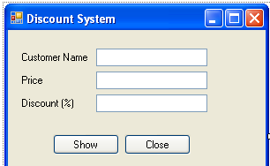

1. Now, I am going to demo how events, properties and methods work in VB.net. So, first double click on the textbox for Customer name which is txtCustomername and you will be in code view/behind as shown below:

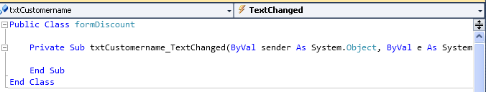

1. Now, the one that has the lightning in a drop down box above are the Events associated with Textboxes. For the meantime you have *TextChanged* event. A TextChanged event is invoke (or called) by VB whenever you change the text or value of your textbox. But that’s not what we want here. So, click on the drop down box *TextChanged* and change it to *KeyDown* instead as shown below.

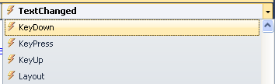

1. A KeyDown event is when you are pressing any key in your keyboard (say a Backspace) before releasing it (hence down). And inside the KeyDown event write the following code below:

If (e.KeyValue = Keys.Enter) Then

txtPrice.Focus()

End If

Now, what we are trying to do above is this. When a user press Enter key we trap it and coming from Customer name we put the focus on the Price textbox named txtPrice using the Focus() method. So, to summarized we use the *KeyDown* **event** and then once it was detected that the user presses Enter key we used the *Focus()* **method** in order to transfer focus to txtPrice.

1. Now, repeat above now this time it would be the *KeyDown* event for txtPrice and trap the Enter key again and transfer focus to txtDiscount textbox. Then the *Keydown* event for txtDiscount trapping enter key again and then transfer the focus to btnShow. The summary of code is shown below.

'For txtPrice Keydown event

If (e.KeyValue = Keys.Enter) Then

txtDiscount.Focus()

End If

'For txtDiscount Keydown event

If (e.KeyValue = Keys.Enter) Then

btnShow.Focus()

End If

1. Now, what we are going to do next is that if the user press or click the Show button then we are going to display amount of discount alongside the name of the customer. So, since we are in code view we need to go back to Design View. So, then click the Form1.vb [Design] tab as shown below to show again the Form.

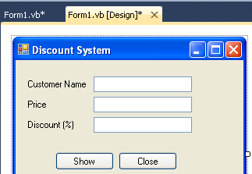

1. Double click the Show button so that we could trap the event when user click the Button and it will show the code behind/view again as shown below.

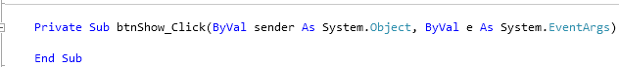

1. Now, inside the btnShow_Click procedure write the following code:

Dim msg As String

Dim discount As String

discount = txtPrice.Text * txtDiscount.Text/100

msg = "Hello! " & txtCustomername.Text & ". You have a $" & discount & " Discount!"

MessageBox.Show(msg, "Discount", MessageBoxButtons.OK, MessageBoxIcon.Information)

1. Now, what we are trying to do here is to declare two variables one for the Message named *msg* and the other one for the computation of discount named *discount*. Then we compute discount by Multipliying Price with Discount over 100 (so as to get the actual percentage). And then create a string that would display the message which include the name and the discount of the customer and store it to *msg* variable.
2. Now, try Run your program and enter the following values:

Customer Name : George

Price : 200

Discount(%) : 10

And it will give you the following output together with the Form window.

